**Aamco transmission cost 800 S4**

**Introduction:**

**In the modern world, almost everyone has a car in a privileged household. The days when there were barely a hundred cars in a whole district have changed so rapidly that now, we have almost ten cars on every street. This shows the technical advancement of our world. But, along with this revolution, the problems too grew technically. Maintaining a car is more important than buying a car and can prove to be expensive sometimes if not taken care of properly. Regular servicing of a car is needed. Methods such as transmission repairing are done to keep the cars and their engines revving as fresh as ever. Transmission repairing is one of the best ways to maintain the vehicles without any problems.**

**Transmission cost in Aamco:**

**In Aamco they first go through our vehicle and perform a 'Vehicle courtesy check' to check how big the issue is. They say that most of the examined cars only had minor problems which were repaired easily. This vehicle courtesy check, valued at 85 USD is done for free in many Aamco service centers. If the transmission has major issues, then Aamco will service it thoroughly and provide a quality transmission rebuild. The transmission cost varies on the scale of damage and the vehicle model and build quality. Geographical location also plays a factor in determining the transmission cost. On average, in Aamco the transmission costs about 2000 USD to 5000 USD. People from different parts of the country with different vehicles have paid different amounts as the fee for transmission. If the car is a normal model and if the spare parts and raw materials are widely available, the prices are expected to be low. But if the customer has exotic and high-end cars, the spare parts may not be available easily which may end in higher pricing for the transmission. Transmission for an ordinary car is around 2000-3500 USD and for exotic high-end vehicles, it is in the range of 3500-5000 USD.**

**What is AAMCO:**

**AAMCO is the abbreviation for Anthony A. Martino Company, named after its founder. They are one of the best automotive companies in the US and are a well-known organization in the field of transmission. This automotive company was founded in Philadelphia of America, in 1957. The present CEO of the company is Jim Gregory, residing in the post since November 2017. Aamco is one of the most successful companies in America thanks to its crafty business plans and techniques. Along with transmission repair, now they also provide ‘total car care’ which takes a complete repairing of the car.**

**What is transmission:**

**Similar to an oil change, transmission service is a regular component of standard auto maintenance. Flushing out the old transmission fluid and substituting it with new fluid is the main component of transmission service. The sump pump or pan should also be examined (if feasible), the filter should be changed or cleaned, the pan should be cleaned, and a new pan gasket should be installed. You should get your gearbox serviced in line with the suggested intervals in your owner's manual. This relies on whether you're driving or owning a car with an automatic transmission or manual transmission.**

**The competition:**

**The performance of the automobile Transmission Manufacturing sector is expected to increase by improving economic conditions. Macroeconomic trends are to lead to increased auto production in the future. There is a lot of competition in the sector due to the opportunities available. Some of the top automotive companies which compete with Aamco are American Axle & Manufacturing Holdings, Inc., Dana Inc., BorgWarner Inc., etc.**

**Why Transmission:**

**As per the current economic situation, rather than buying a new car, it is more economical to maintain and repair the existing vehicle. Transmission repair saves us a lot of money which we can invest elsewhere to gain profits. It is said so because due to the recent Covid-19 pandemic economy has taken a hit and the cost of raw materials increased. As a result, the prices of cars too went high. Also, the depreciation rate of the recent models is very high as they lose about 30-35% of their original value. We can prevent high monthly payments for these cars that snack on the bank balances by just investing short-term on repairing the existing vehicle.**

**Conclusion:**

**Aamco has done a great job with their transmission as they have decent customer reviews across the country. Their services are customer friendly, its prices are also a bit lower than their competitors. Transmission of cars should be encouraged as it not only saves cost but also preserves the environment as automobile manufacturers give out a lot of waste which is harmful to the environment. By just repairing the vehicle instead of buying a new one, we are doing a favor to ourselves and also to our world in which our future generations will live happily.**

**FAQ:**

1. **Is it necessary to do transmission?**

**It is important to recheck if everything is fine with your car. It will help to maintain the car smoothly without any problems and also increases its life. So, it is necessary.**

1. **How often should I do the transmission?**

**It depends on the vehicle model and condition. Experts prefer rechecking and transmitting a vehicle for every 30,000 miles it runs.**

1. **Should I transmit my old car or buy a new one?**

**It is preferred that you transmit the old car rather than buying a new one as it saves a lot of money and also extends the life of the existing vehicle.**

**Spinmenot screenshot:**

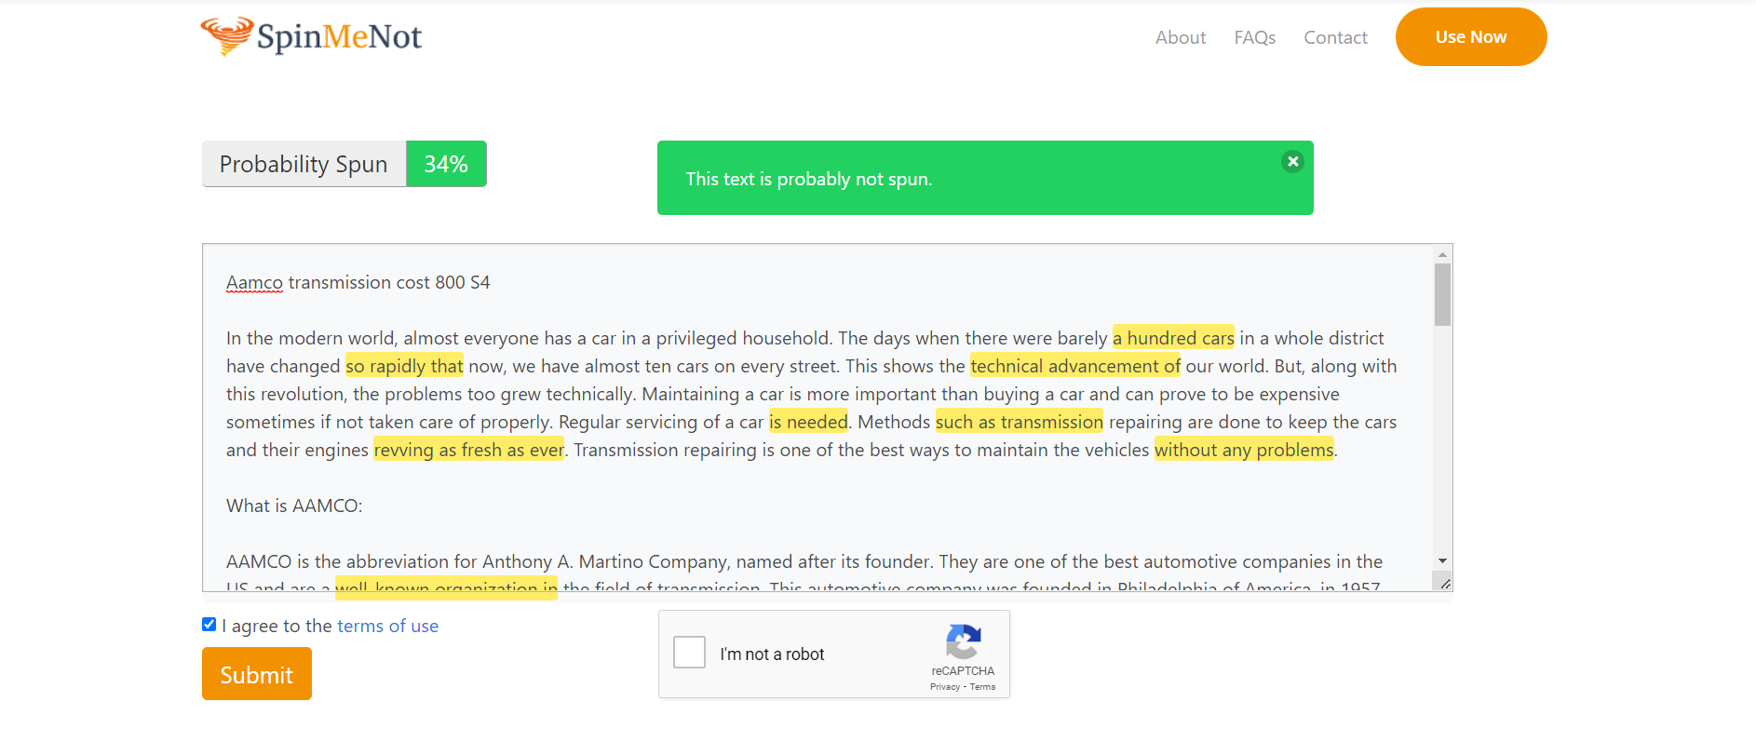

**Grammarly screenshot:**

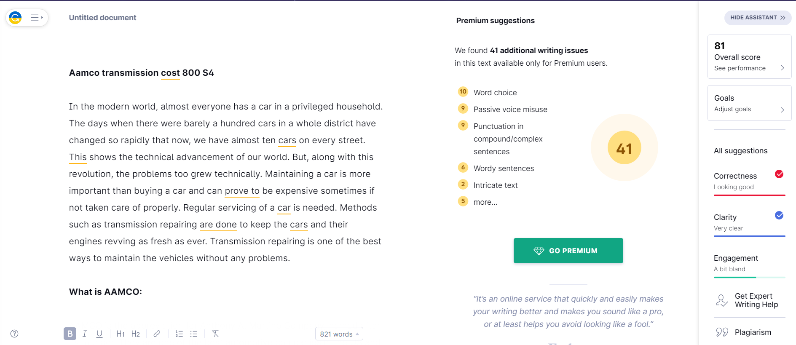

**Quetext screenshot:**

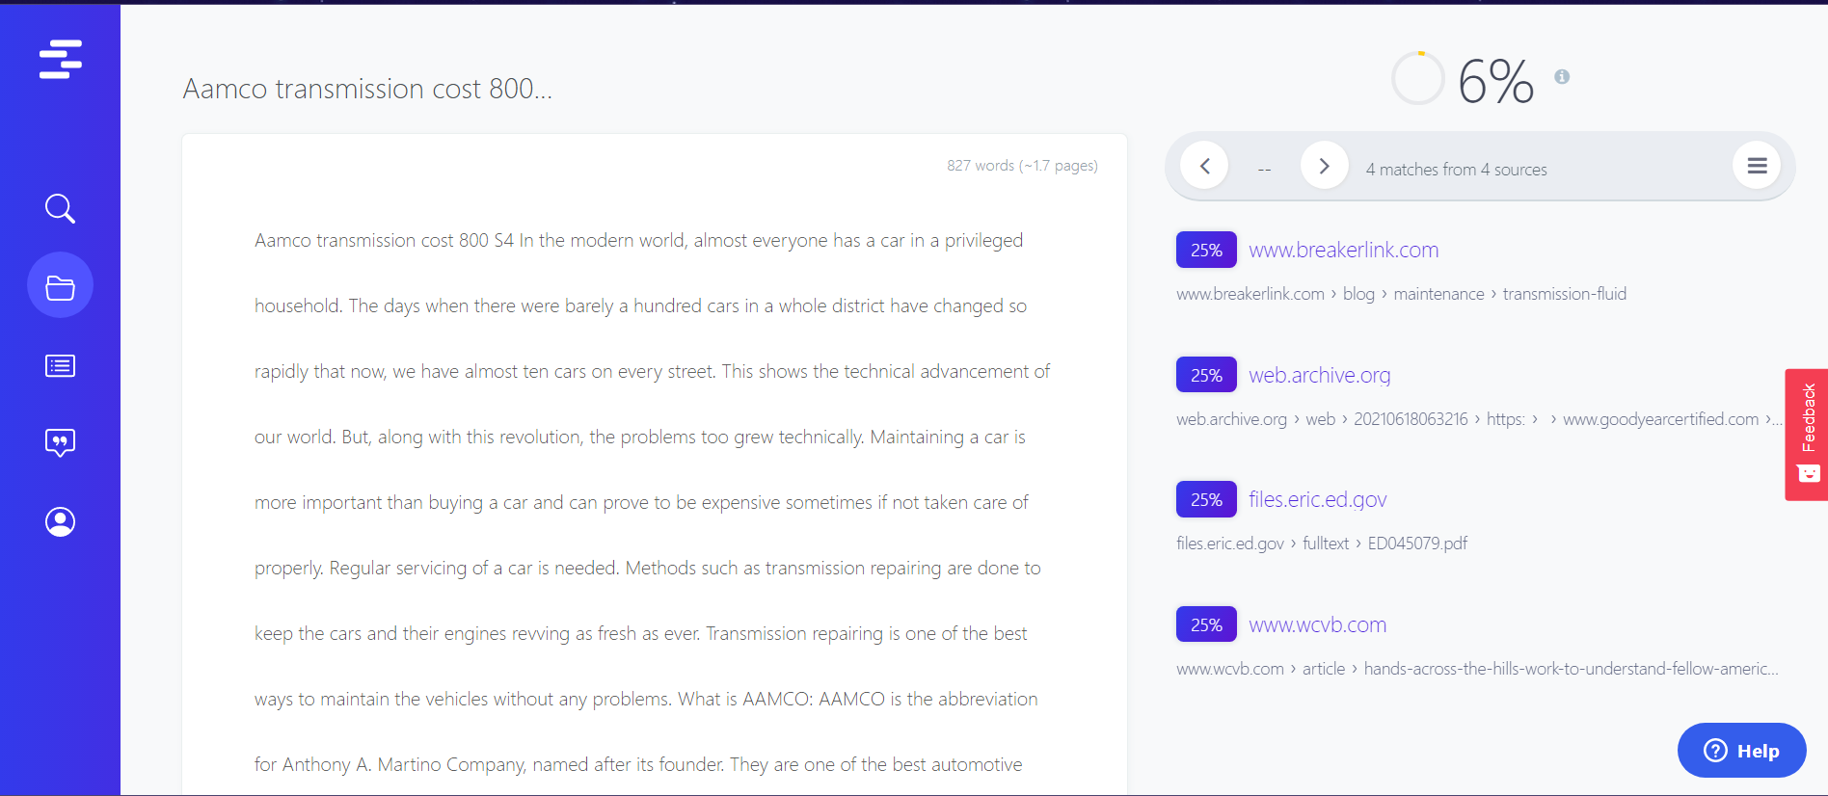

* **Article by Sanjay M.**